all-purpose fishing boats
back to boat types
Fishing, in all its varieties, leads to boats. And for many anglers, an all-purpose fishing boat is a perfect choice. Many look a little like a bass boat, but with a deeper-angled hull and higher sides. Many have partial or full windscreens. These boats can carry a family or just a couple of buddies on rivers and lakes, freshwater and saltwater, for everything from panfish to big game.
An all-purpose fishing boat can come with a car-like steering wheel or with a steering (and throttle) lever called a tiller on the outboard motor. Most have rod lockers and livewells, which are cooler-like built-ins that deliver fresh, well-oxygenated water to keep fish or bait alive. Some come equipped with rod holders. Yours might have an electric trolling motor at the bow or at the stern beside the powerful gasoline-powered outboard that scoots you from place to place.

Quick Stats
- freshwater fishing
- 8 Max
- 8 - 24 ft
- outboard engine
- man power
- trailerable
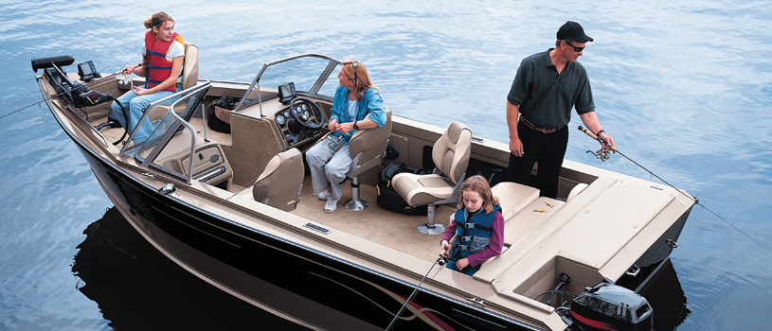
All-purpose fishing boats are designed for general use, primarily for and by anglers.
PrevNext

Boat Brands & Manufacturers
A B C D E F G H I J K L M N O P Q R S T U V W X Y Z ALL
Alumacraft

ArrowCat

Bahama Boatworks

Boston Whaler
Campion

Carolina Cat Boats

Carolina Skiff

Chris-Craft
Cobia Boats

Concept Boats

Crestliner Boats

Duckworth Boats
EdgeWater Power Boats

G3 Boats

Glacier Bay Cats

Grizzly
Harris FloteBote

Hewes Boats

Invincible Boats

Larson Boats
Larson FX

Lowe Boats

Lund Boats

MAKO
MirroCraft

Misty Harbor Boats

Monark Marine

Nitro
Northwest Boats

Pathfinder Boats

Polar Kraft

Pond King
Princecraft

Ranger Aluminum

Ranger Boats

Sailfish Boats
Sea Ark Boats

Sea Chaser

Sea Vee Boats

Skeeter Boats
Smoker Craft

Sportsman

Starcraft Marine

Stingray Boats
Stratos

Striper Boats

Sun Tracker

Sylvan
Tracker Boats

Triumph Boats

Weldcraft

Weldcraft Marine
World Cat

Xpress Boats - Aluma-Weld

